1. **Agenda**:
   1. How to make the msg dynamic in the following slide taken from the last lecture.  
      Graphical user interface, text, application, website

      Description automatically generated
2. One of the options that we can do is actually create a bean to generate that message.
   1. Chart

      Description automatically generated
   2. Default and Different way configuration. (Actually this was discussed earlier than the above one in the lecture but I though the order should be this)  
      The following configuration and the above configuration both are effectively same.
   3. 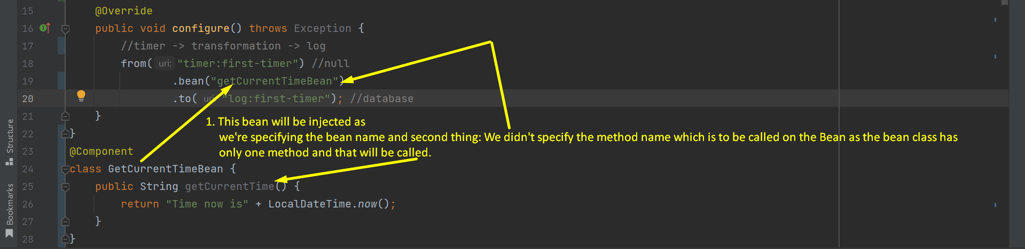
3. **There are two things we can do within a route**:
   1. **Processing**: When we’re using the msg without changing it.
   2. **Transformation**: When we’re changing the actual msg.
4. **Transformation**:
   1. If we’re changing.
5. Text

   Description automatically generated**NOTE**: The above **SimpleLoggingProcessingComponent.process(String)** doesn’t return anything as this is processing the msg without changing it.